**APP.JS:**

import React, { useState } from 'react';

import Greeting from './Greeting';

import LoginButton from './LoginButton';

import LogoutButton from './LogoutButton';

function App() {

const [isLoggedIn, setIsLoggedIn] = useState(false);

const handleLoginClick = () => setIsLoggedIn(true);

const handleLogoutClick = () => setIsLoggedIn(false);

return (

<div>

<Greeting isLoggedIn={isLoggedIn} />

{isLoggedIn ? (

<LogoutButton onClick={handleLogoutClick} />

) : (

<LoginButton onClick={handleLoginClick} />

)}

</div>

);

}

export default App;

**LOGOUT.JS:**

import React from 'react';  
  
function LogoutButton(props) {  
 return (  
 <button onClick={props.onClick}>  
 Logout  
 </button>  
 );  
}  
  
export default LogoutButton;

**GREETING.JS:**

import React from 'react';

import UserGreeting from './UserGreeting';

import GuestGreeting from './GuestGreeting';

function Greeting(props) {

const isLoggedIn = props.isLoggedIn;

if (isLoggedIn) {

return <UserGreeting />;

}

return <GuestGreeting />;

}

export default Greeting;

**GUESTGREETING.JS**

import React from 'react'

function GuestGreeting(){

return <h1>Please sign up</h1>;

}

export default GuestGreeting;

**LOGINBUTTON.JS:**

import React from 'react';

function LoginButton(props) {

return (

<button onClick={props.onClick}>

Login

</button>

);

}

export default LoginButton;

**INDEX.JS:**

import React from 'react';

import ReactDOM from 'react-dom/client';

import App from './App';

const root = ReactDOM.createRoot(document.getElementById('root'));

root.render(<App />);

**OUTPUT:**

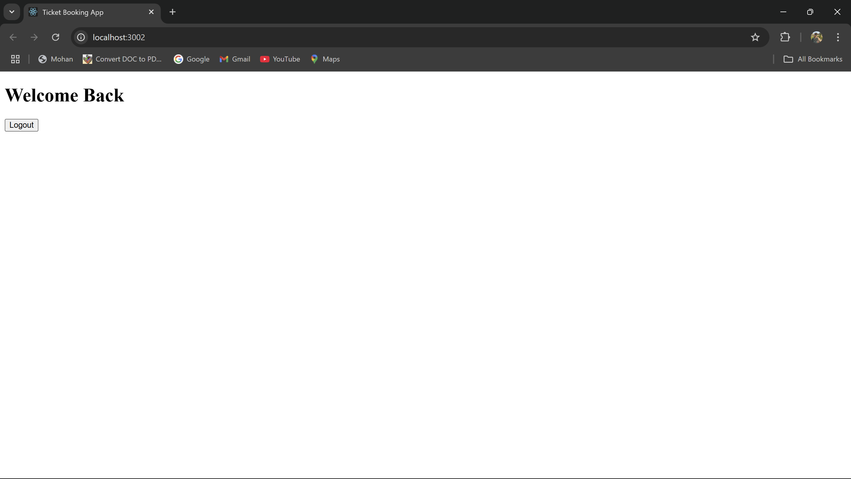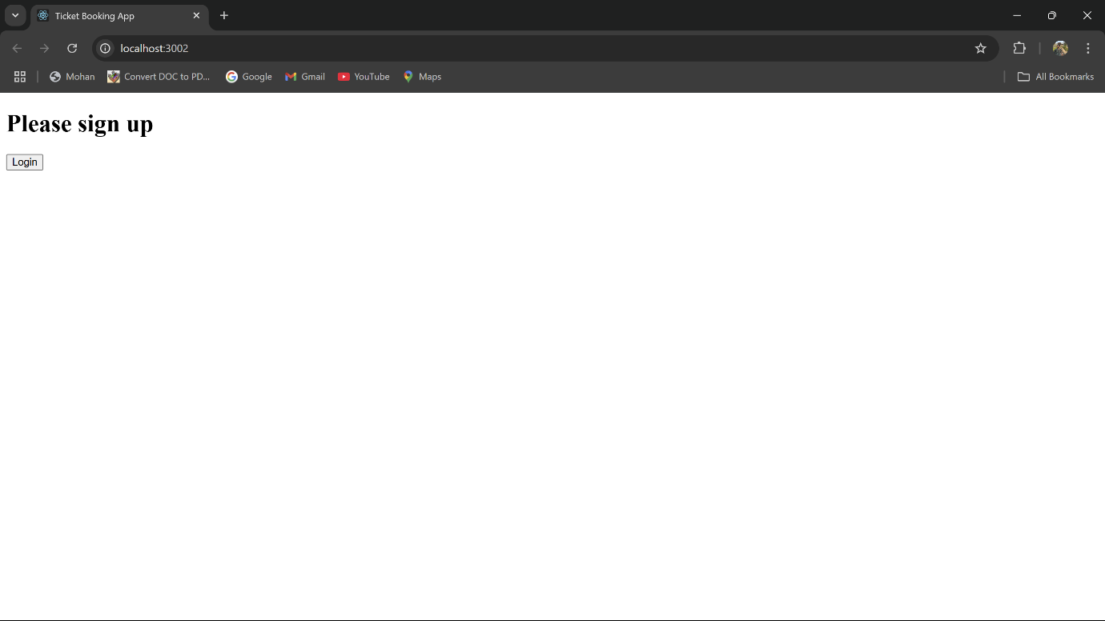

**APP.JS:**

import React from 'react';  
import PlayerList from './PlayerList';  
import LowScoreList from './LowScoreList';  
  
function App() {  
 const players = [  
 { name: 'Sai Sudharsan', score: 90 },  
 { name: 'Rishabh Pant', score: 85 },  
 { name: 'Dhoni', score: 60 },  
 { name: 'Jadeja', score: 65 },  
 { name: 'Gill', score: 70 },  
 { name: 'Sundar', score: 50 },  
 { name: 'Virat', score: 80 },  
 { name: 'Anul', score: 70 },  
 { name: 'Rohit', score: 55 },  
 { name: 'Jaiswal', score: 50 },  
 { name: 'Raina', score: 95 },  
 ];  
  
 return (  
 <div style={{ padding: '20px' }}>  
 <h1>Cricket App</h1>  
 <PlayerList players={players} />  
 <LowScoreList players={players} />  
 </div>  
 );  
}  
  
export default App;

**INDEX.HTML:**

<!DOCTYPE html>  
<html lang="en">  
<head>  
 <meta charset="UTF-8" />  
 <title>React App</title>  
</head>  
<body>  
<div id="root"></div>  
</body>  
</html>

**INDEX.JS:**

import React from 'react';  
import ReactDOM from 'react-dom/client';  
import App from './App';  
  
const root = ReactDOM.createRoot(document.getElementById('root'));  
root.render(<App />);

**PLAYERLIST.JS:**

import React from 'react';  
  
function PlayerList({ players }) {  
 return (  
 <div>  
 <h2>All Players</h2>  
 <ul>  
 {players.map((player, index) => (  
 <li key={index}>  
 {player.name} - {player.score}  
 </li>  
 ))}  
 </ul>  
 </div>  
 );  
}  
  
export default PlayerList;

**LOWSCORELIST.JS:**

import React from 'react';  
  
function LowScoreList({ players }) {  
 const lowScorers = players.filter(player => player.score < 70);  
  
 return (  
 <div>  
 <h3>Players with Below the score of 70</h3>  
 <ul>  
 {lowScorers.map((player, index) => (  
 <li key={index}>  
 {player.name} - {player.score}  
 </li>  
 ))}  
 </ul>  
 </div>  
 );  
}  
  
export default LowScoreList;

**OUTPUT:**

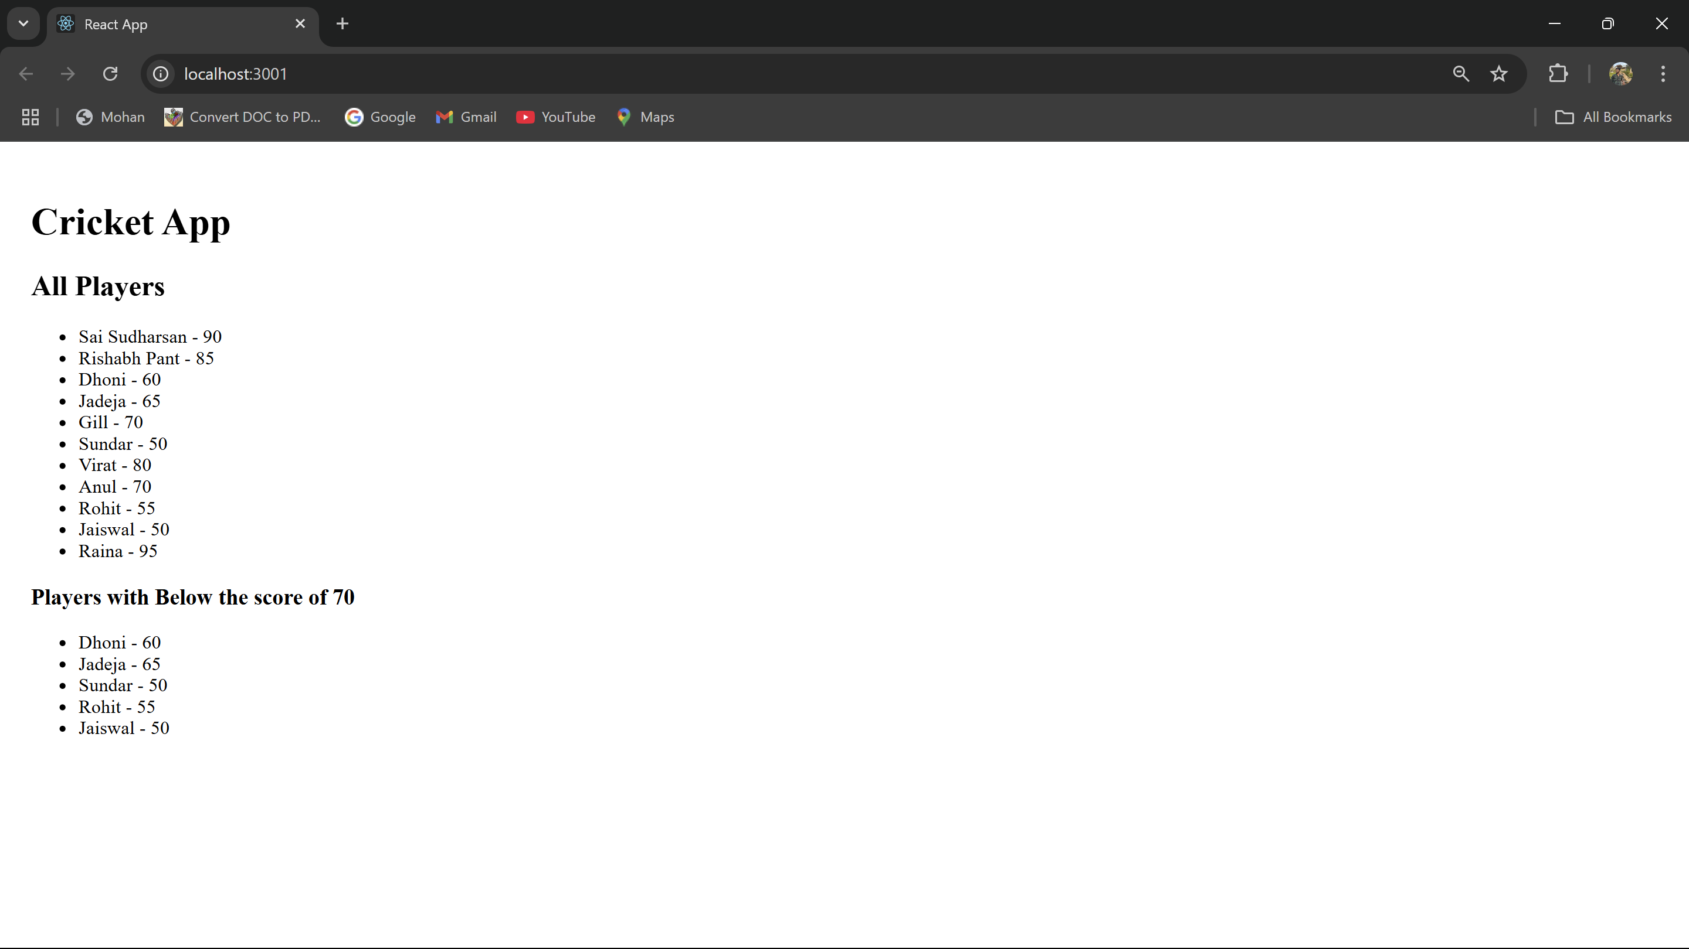

**APP.JS:**

import React from "react";  
  
function App() {  
 const officeList = [  
 { Name: "Cognizant", Rent: 50000, Address: "Chennai" },  
 { Name: "ITWorks", Rent: 75000, Address: "Bangalore" },  
 { Name: "Himalayas", Rent: 60000, Address: "Hyderabad" },  
 { Name: "Smartworks", Rent: 55000, Address: "Pondicherry" },  
 ];  
  
 const imageStyle = {  
 width: "25%",  
 height: "25%",  
 };  
  
 return (  
 <div>  
 <h1>Office Space, at Affordable Range</h1>  
 <img  
 src="https://via.placeholder.com/300"  
 alt="Office Space"  
 style={imageStyle}  
 />  
  
 {officeList.map((item, index) => {  
 const rentColor = {  
 color: item.Rent <= 60000 ? "red" : "green",  
 };  
  
 return (  
 <div key={index}>  
 <h2>Name: {item.Name}</h2>  
 <h3 style={rentColor}>Rent: Rs. {item.Rent}</h3>  
 <h3>Address: {item.Address}</h3>  
 <hr />  
 </div>  
 );  
 })}  
 </div>  
 );  
}  
  
export default App;

**OUTPUT:**

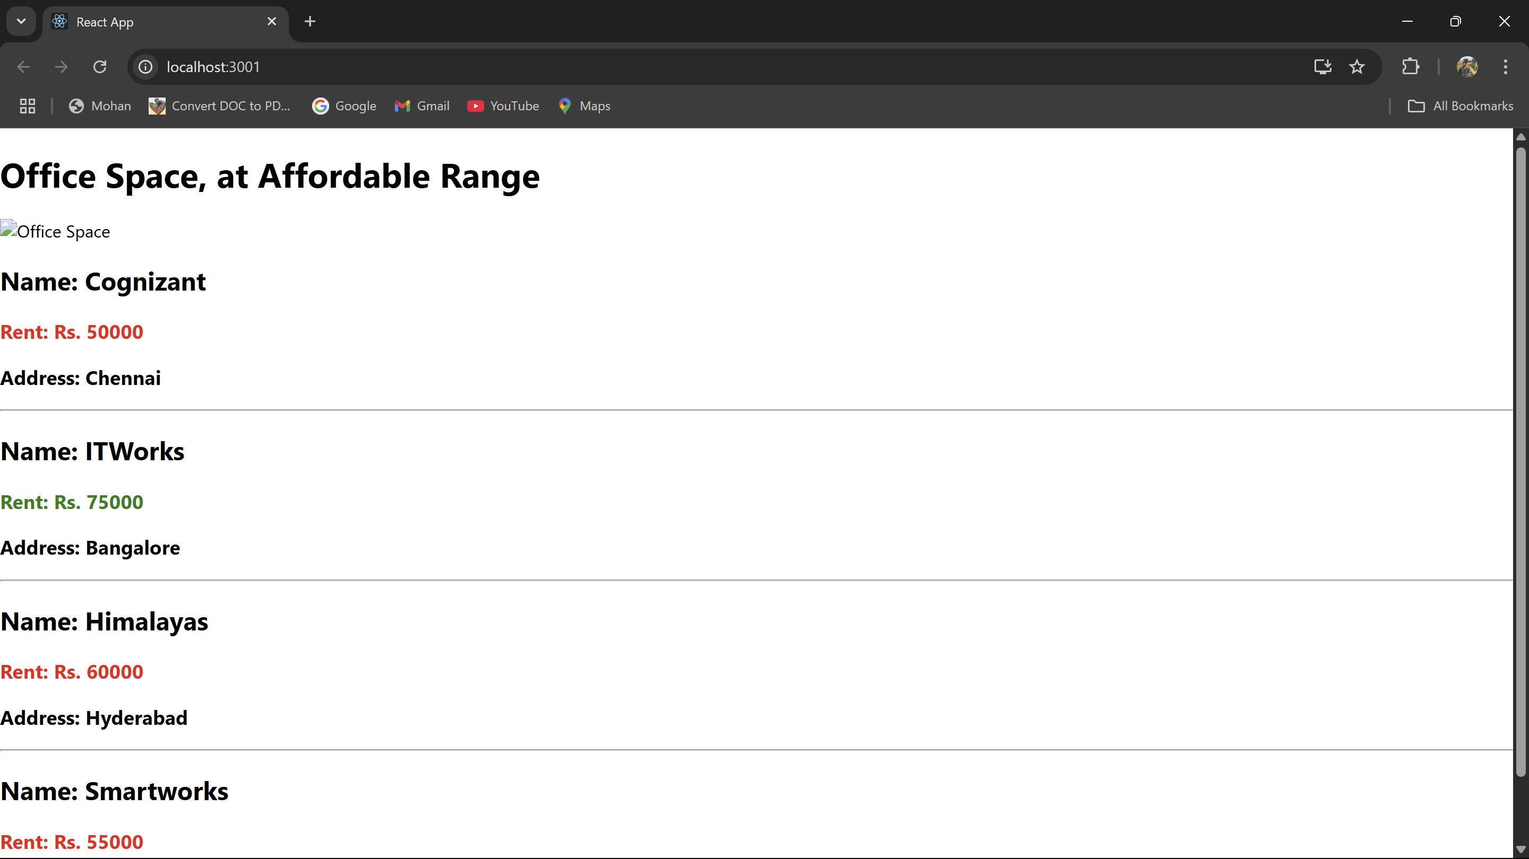

**APP.JS:**

import React from 'react';  
import './App.css';  
import Course from './components/Course';  
import Book from './components/Book';  
import Blog from './components/Blog';  
  
function App() {  
 return (  
 <div className="container">  
 <Course />  
 <Book />  
 <Blog />  
 </div>  
 );  
}  
  
export default App;

**INDEX.JS:**

import React from 'react';  
import ReactDOM from 'react-dom/client';  
import App from './App';  
  
const root = ReactDOM.createRoot(document.getElementById('root'));  
root.render(<App />);

**BLOG.JS:**

import React from 'react';  
import '../App.css';  
  
function Blog() {  
 return (  
 <div className="section">  
 <h2>Blog Details</h2>  
  
 <div>  
 <div className="item-title">React Learning</div>  
 <div className="item-sub"><strong>Stephen Biz</strong></div>  
 <div className="item-sub">Welcome to learning React!</div>  
 </div>  
  
 <div style={{ marginTop: '20px' }}>  
 <div className="item-title">Installation</div>  
 <div className="item-sub"><strong>Schewzdenier</strong></div>  
 <div className="item-sub">You can install React from npm.</div>  
 </div>  
 </div>  
 );  
}  
  
export default Blog;

**BOOK.JS:**

import React from 'react';  
import '../App.css';  
  
function Book() {  
 return (  
 <div className="section">  
 <h2>Book Details</h2>  
 <div>  
 <div className="item-title">Master React</div>  
 <div className="item-sub">670</div>  
 </div>  
 <div>  
 <div className="item-title">Deep Dive into React</div>  
 <div className="item-sub">800</div>  
 </div>  
 <div>  
 <div className="item-title">Learing the basics of Java</div>  
 <div className="item-sub">450</div>  
 </div>  
 </div>  
 );  
}  
  
export default Book;

**COURSE.JS:**

import React from 'react';  
import '../App.css';  
  
function Course() {  
 return (  
 <div className="section">  
 <h2>Course Details</h2>  
 <div>  
 <div className="item-title">Angular</div>  
 <div className="item-sub">4/5/2021</div>  
 </div>  
 <div>  
 <div className="item-title">React</div>  
 <div className="item-sub">6/3/2021</div>  
 </div>  
 </div>  
 );  
}  
  
export default Course;

**APP.CSS:**

.container {  
 display: flex;  
 justify-content: center;  
 align-items: flex-start;  
 height: 100vh;  
 padding: 40px;  
 font-family: Arial, sans-serif;  
}  
  
.section {  
 padding: 0 40px;  
}  
  
.section:not(:last-child) {  
 border-right: 4px solid green;  
}  
  
.section h2 {  
 font-size: 24px;  
 margin-bottom: 20px;  
}  
  
.item-title {  
 font-weight: bold;  
 font-size: 18px;  
 margin-top: 10px;  
}  
  
.item-sub {  
 font-size: 14px;  
 color: #333;  
}

**OUTPUT:**

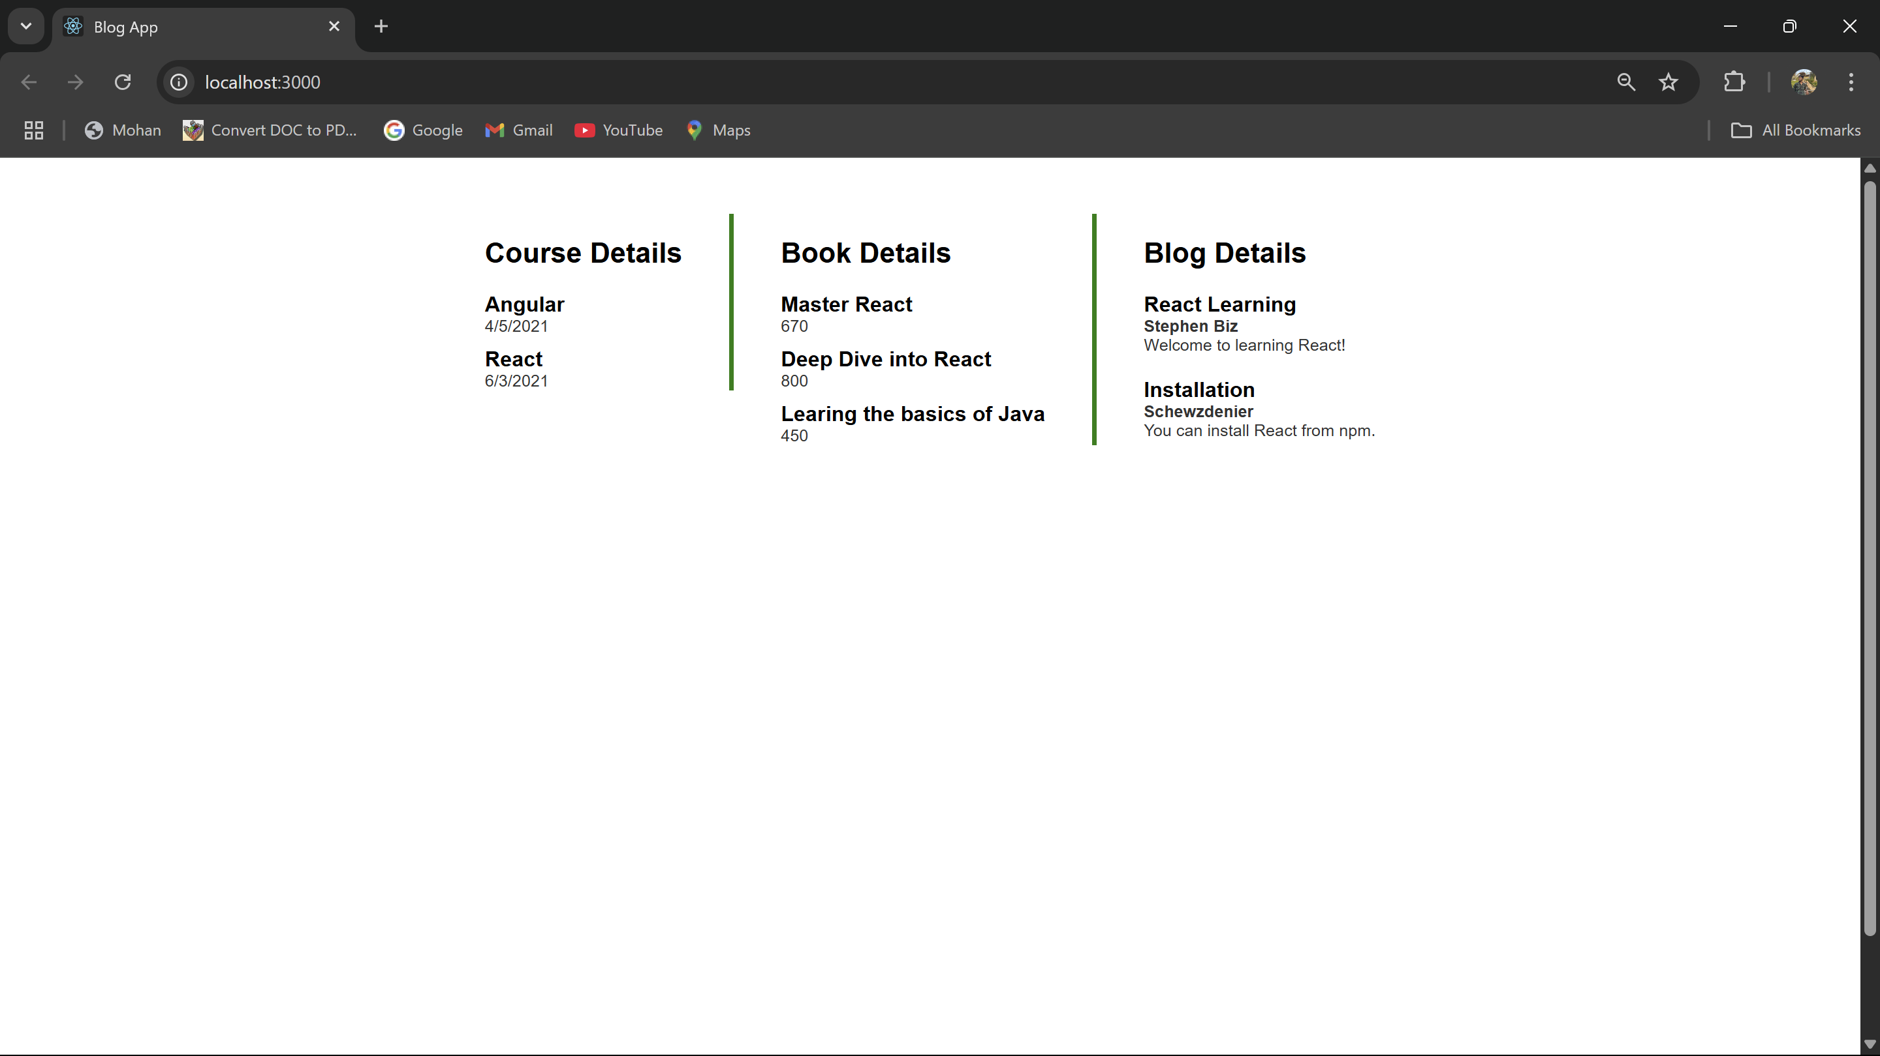

**APP.JS:**

import React from 'react';  
import Counter from './Counter';  
import SayWelcome from './SayWelcome';  
import SyntheticEventButton from './SyntheticEventButton';  
import CurrencyConvertor from './CurrencyConvertor';  
  
function App() {  
 return (  
 <div className="App">  
 <h1>ReactJS Events Example</h1>  
 <Counter />  
 <SayWelcome name="Deva" />  
 <SyntheticEventButton />  
 <CurrencyConvertor />  
 </div>  
 );  
}  
  
export default App;

**CURRENCYCONVERTER.JS:**

import React, { useState } from "react";  
import "./App.css";  
  
function CurrencyConverterApp() {  
 const [amount, setAmount] = useState("");  
 const [currency, setCurrency] = useState("");  
 const [converted, setConverted] = useState("");  
  
 const handleSubmit = (e) => {  
 e.preventDefault();  
 if (currency.toLowerCase() === "euro") {  
 setConverted(`₹${(amount * 90).toFixed(2)}`);  
 } else if (currency.toLowerCase() === "rupee") {  
 setConverted(`€${(amount / 90).toFixed(2)}`);  
 } else {  
 setConverted("Invalid currency");  
 }  
 };  
  
 return (  
 <div className="container">  
 <h2>Currency Converter</h2>  
 <div className="section">  
 <form onSubmit={handleSubmit}>  
 <label>Amount: </label>  
 <input  
 type="number"  
 value={amount}  
 onChange={(e) => setAmount(e.target.value)}  
 required  
 />  
 <br />  
 <label>Currency (euro/rupee): </label>  
 <input  
 type="text"  
 value={currency}  
 onChange={(e) => setCurrency(e.target.value)}  
 required  
 />  
 <br />  
 <button type="submit">Submit</button>  
 </form>  
 <p>{converted}</p>  
 </div>  
 </div>  
 );  
}  
  
export default CurrencyConverterApp;

**COUNTER.JS:**

import React, { useState } from "react";  
import "./App.css";  
  
function CounterApp() {  
 const [counter, setCounter] = useState(0);  
  
 const handleIncrement = () => setCounter(counter + 1);  
 const handleDecrement = () => setCounter(counter - 1);  
  
 return (  
 <div className="container">  
 <h2>Counter</h2>  
 <div className="section">  
 <p>Counter Value: {counter}</p>  
 <button onClick={handleIncrement}>Increment</button>  
 <button onClick={handleDecrement}>Decrement</button>  
 </div>  
 </div>  
 );  
}  
  
export default CounterApp;

**SAYWELCOME.JS:**

import React from 'react';  
  
function SayWelcome({ name }) {  
 const welcome = (person) => {  
 alert(`Welcome, ${person}!`);  
 };  
 return (  
 <div>  
 <button onClick={() => welcome(name)}>Say Welcome</button>  
 </div>  
 );  
}  
  
export default SayWelcome;

**SYNTHETICEVENTBUTTON:**

import React from 'react';  
  
function SyntheticEventButton() {  
 const onPress = (event) => {  
 alert('I was clicked');  
 };  
 return (  
 <div>  
 <button onClick={onPress}>Click me</button>  
 </div>  
 );  
}  
  
export default SyntheticEventButton;

**OUTPUT:**

